AA Croydon, Epsom & Sutton Intergroup’s
Families in Recovery

Saturday 21st April 2018
1.30pm to 5.30 pm
- An afternoon of talks and discussion with Al-Anon participation.
- Children are very welcome! Supervised activities will be provided in a separate room.
- All meetings are open.
- No charge for admission - for fun and for free! 7th tradition will be observed.
Christ Church with St Philip  Ruskin Drive  Worcester Park  KT4 8LG | 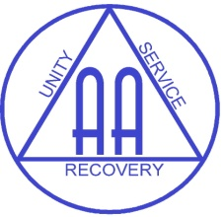

CESIG AA “Families in Recovery”
“Now comes the biggest question yet. What about the practice of these principles in all our affairs? Can we love the whole pattern of living as eagerly as we do the small segment of it we discover when we try to help other alcoholics achieve sobriety? Can we bring the same spirit of love and tolerance into our sometimes deranged family lives that we bring to our A.A. group?”
12&12 Step Twelve, pp.111-112

13.30 | Doors open – tea, coffee and fellowship
14.00 – 15.30 | Shared platform AA & Al-Anon speaker meeting
15:30 – 16:00 | Tea and cake
16:00 – 17:30 | AA speaker with sharing back from the floor
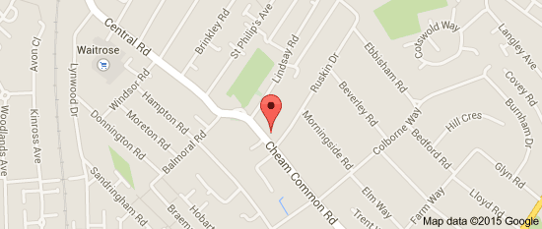 |  | The 151 and 213 buses stop very close to the church. You need to get off at the “Lindsay Road” bus stop.  If you are travelling by train, the nearest station is Worcester Park. From the station, it takes about 15 minutes to walk to the church.  The car park can be accessed from Ruskin Drive. There is also on street parking available on Ruskin Drive and adjacent roads.
For information contact
cesigsec@yahoo.com or Becca: 07545 985 374

