Regional PI Report – May 2023. PI / Employment / Health / Young Persons
Southeast Region
The main activity has been the House of Commons Parliamentary Event which took place at Portcullis House on Tuesday May 16th. The event was very well attended by a variety of services, charities, and companies with approximately fifty attendees. The agenda was as below.
- Welcome from the event sponsor, Mr Steve Brine - MP for Winchester
- Speech from Louise Foxcroft Non-Alcoholic trustee
- Speech by Kieran Lynch, Senior Substance Misuse Integration Manager, NHS England
- Shares from 2 AA members
- Q&A

Ellie would like to remind all Liaison Officers that we have a Liaison Officer WhatsApp group, if there are LO’s in your intergroup who would like to be added then then can contact her on 07899796274. There is also a PI Facebook page which is a great forum to share and obtain ideas. Anyone wishing to join should send a Facebook friend request to Ellie Woodward and then they can be invited to the Private Facebook group.
Finally, a reminder of the Workshops and Seminars held at York for the various service positions. Whilst the Seminars are primarily for Regional Officers, where we do not currently have a Regional Officer in post, we would encourage an Intergroup Liaison Officer to attend to represent SE Region.
- 9/10 June - Regional Employment Liaison Officers Meeting
- 24th June - Finance Seminar
- 30th June - Regional Prison & Probation Liaison Officer meeting - this will be followed by the Seminar on the 1st of July.
- 7/8 July - Regional Chairs Meeting
- 14/15 July - Regional Secretaries Meeting
- 4/5 August - Regional Electronic Liaison Officers Meeting
- 11/12 August - Regional Telephone Liaison Officers Meeting
- 18/19 August - Regional Young Persons Liaison Officers Meeting
- 1/2 September - Regional Public Information Liaison Meeting (this may be subject to a date change)
- 22/23 September - Network Archivist Meeting
- 29/30 September - Regional Health Liaison Officers Meeting
- 29/30 September - Regional Share Liaison Officers Meeting

Brighton YPLO
Since last week we have managed to get an aa meeting/presentation into the YMCA Portslade. We will be attending every fortnight till Dec 2023. I take another member with me and plenty of aa literature.
Sasha is still liaising with the young person’s service RU ok? In Brighton, and recently have sent two young members to meet with 2 Young service users (with their key workers present) to carry the aa message.
Brighton ELO
Lee is still following up with trying to get a stand at this year’s Brighton Pride, he has sent emails to two of the pride organisers, unfortunately he has not yet had a response but will keep us informed of any progress.
East Kent PILO
Ant is working his way around the local groups explaining the PI roll and leaving information for the groups to help distribute.
Working very closely with HLO EK/ WKIG and have done presentations on the 6th and the 24th of March with Canterbury Christ Church University, and have done presentations at Kent University 23rd May and the 1st of June
We have an article in a local newspaper, reaching 100,000 homes in East Kent and have approached local free newspapers regarding advertising.
Ant is reconnecting links with Forward Trust regarding people leaving prison on the road to recovery, which is slowly Bearing fruit. I have contacted families in Crisis, and they are very keen on having us to share our experience on alcoholism. No response yet.
The team are exploring many other ways of spreading the message of recovery, a community centre, doctors Surgeries, police stations and workplaces.
Also, East Kent are starting a poster campaign on buses, telephone bosses and an advert the local radio stations.
East Sussex PILO
Schools / Young person
- Our current process, which is presenting a 50min lesson to Y8/Y9 pupils (age 13/14) as part of their RSHE curriculum, has been completed for the year (8 sessions)
- Our liaison officer, Bob, has been working with the East Sussex, Head of Health Education, and a new process has been initiated for a 25minute special assembly for 6th Formers (age 18/19)
- Three assemblies to 6th formers have now been given, one at East Sussex University, and two at Seaford Head School.
- This is easier to organise, can be done at most schools in one or two visits, rather than the 6 to 10 visits per school per year that we currently do, and will target pupils who probably have already started to drink and experiment with mind-changing substances.
- Following these, Bob will meet with Sam Whittaker again with a view to scheduling this new format to 6th formers at all schools within his remit in the County.
Health
- Contacted by Nurse Consultant Dual Diagnosis at Sussex Partnership NHS Foundation Trust who is looking to develop stronger links with AA 12 step program.
- Meeting set up for mid-June with ESIG HLO, but I have had no response from HLO's in Brighton & Hove or West Sussex. If this could be raised at Region, I would be grateful and happy to liaise between the Intergroups and SPNHS.
PI Working Group
- First Working Group meeting to be scheduled in June via Zoom.
- One to one discussion with E Comms, Employment, Health, Schools, Armed Forces have all identified their preference to work as a team and share experience and ideas.
Southern Convention (Haywards Heath)
- Details of Darkness into Light exhibition contact provided to convention committee member

Mid Surrey PILO
The Alcoholics Anonymous and Al-Anon Public Information event on 26th April held at the Guildhall, Guildford, was a huge success and we received very positive feedback on the forms. Yvette would like to thank the team from the two Fellowships for all their hard work.
Representatives from the following organisations attended:
- Samaritans
- United Reformed Church Guildford
- Catalyst
- Surrey Care Trust
- Transform Housing and Support
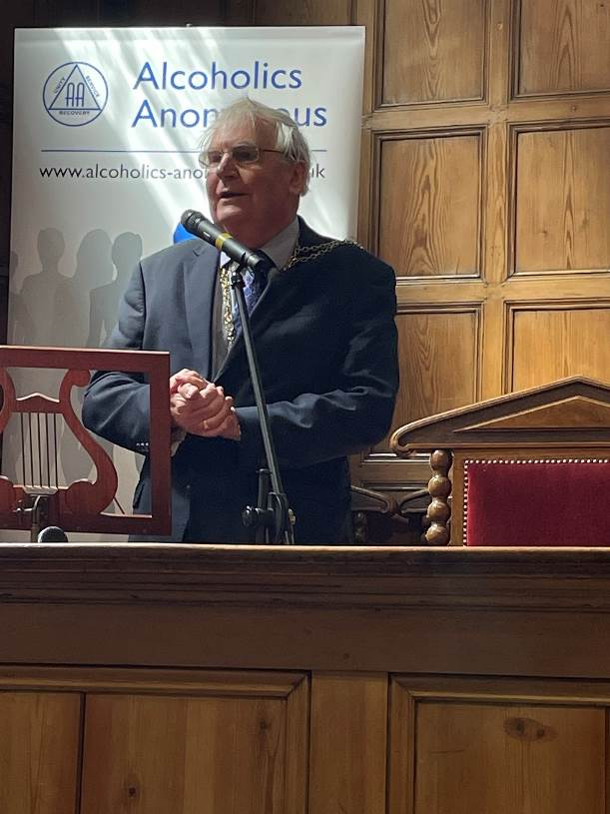
- DWP – various sites
- Voluntary Actions SW Surrey
- Social Prescribing
- Action for Carers
- Vaughan House Guildford
- One You Surrey
